## **Translations Builder Installation Guide**

This installation guide will walk you through the installation process to get Translations Builder up and running on the same machine you use to work with Power BI Desktop. Before installing **Translations Builder**, you must ensure your computer meets the following requirements.

* 64-bit Version of Windows 10 or Windows 11
* 64-bit version of Power BI Desktop (November 2022 or later)
* .NET 6 Runtime for Desktop Applications ([download install files](https://dotnet.microsoft.com/en-us/download/dotnet/thank-you/runtime-desktop-6.0.8-windows-x64-installer)).

### Download and Run the Installer MSI File

To install **Translations Builder**, begin by downloading [**TranslationsBuilderInstall.msi**](https://github.com/PowerBiDevCamp/TranslationsBuilder/raw/main/SetupFiles/TranslationsBuilderInstaller.msi).

When you click this download link, the browser should download the MSI file named **TranslationsBuilderInstall.msi** and place this file in the local **Downloads** folder. The browser should show that **TranslationsBuilderInstall.msi** has been downloaded and provide a context menu of actions. The following screenshot shows what this experience looks like when using Google Chrome. Other browsers will provide a different experience.

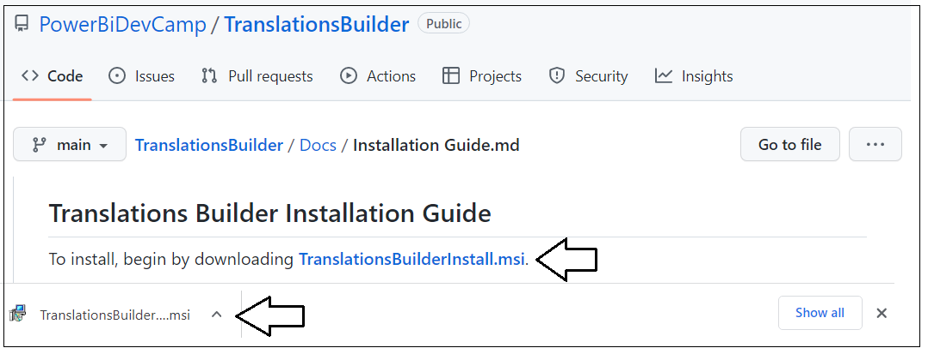

Note that the installation file named **TranslationsBuilderInstall.msi** has not been signed using Authenticate to verify the authenticity of the code manufacturer which is Power BI Dev Camp. We are currently in the process of obtaining a code-signing certificate for Power BI Dev Camp which will make the installation process smoother in the future. But for now, there are some extra steps to go through during installation because the Window operating system cannot verify who the publisher is.

Open to context menu for **TranslationsBuilderInstall.msi** and select **Open** to run the installation program.

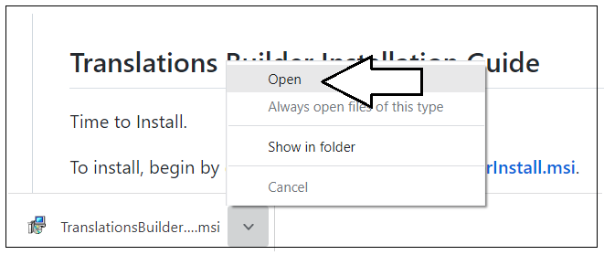

Because **TranslationsBuilderInstall.msi** is not signed with a code-signing certificate, you will be prompted with the following dialog with the title **Windows protected your PC dialog**. Click the **More info** link to continue.

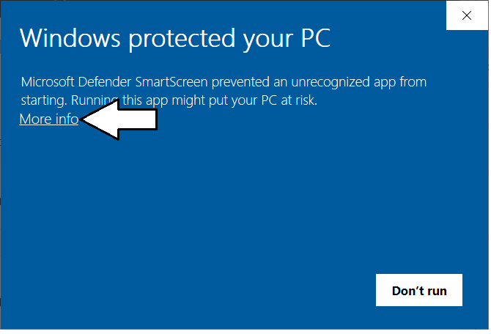

The next screen displays the name of the **App** as **TranslationsBuilderInstall.msi** and indicates that the publisher is unknown. Click the **Run anyway** button to begin the installation process.

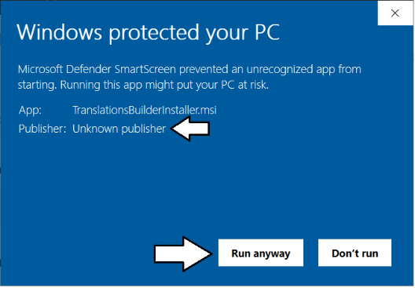

When you see the **Welcome** screen of the **Translations Builder Setup Wizard**, click **Next** to continue,

On the **Select Installation Folder** page, accept the default **Folder** location value and click **Next**.

Do not change default **Folder** path value of **C:\Program Files\Power BI Dev Camp\Translations Builder\**. The reason you should avoid changing the **Folder** location is the installation program copies a file named **translationsbuilder.pbitool.json** into the special folder for Power BI Desktop external tools and that file has the hardcoded path of the default **Folder** location. If you change the **Folder** location from the default value, then you will need to update the file named **translationsbuilder.pbitool.json** which is explained at the end of this article in the Troubleshooting section.

On the **Confirm Installation** page, click **Next** to continue.

At this point, you should be prompted by the **User Account Control** dialog. Click **Yes** to continue.

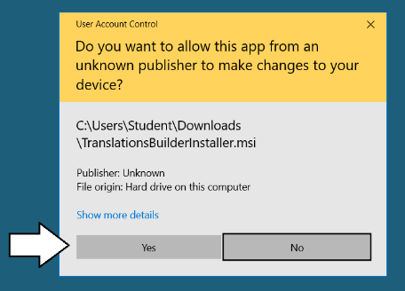

Wait until you see the **Installation Complete** dialog and then click **Close** to complete the installation process.

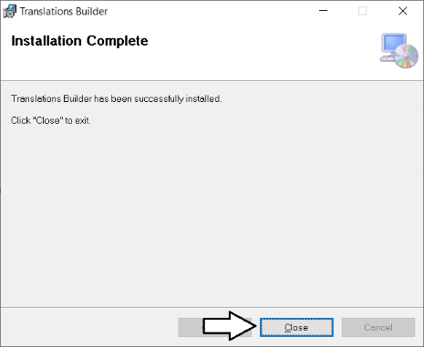

Now that **Translations Builder** has been installed, you should be able to launch it from Power BI Desktop as an external tool.

1. Open Power BI Desktop.
2. Navigate to the **External Tools** tab.

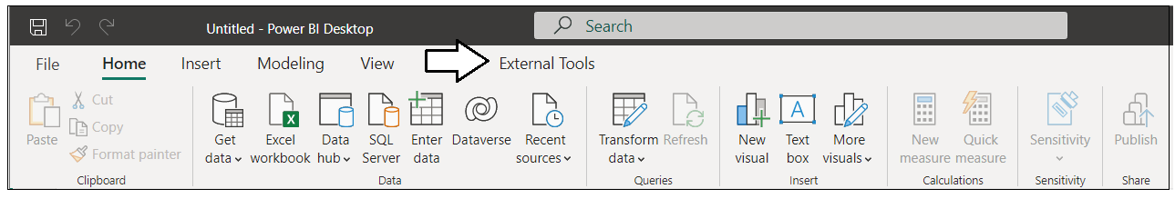

1. Locate and click the **Translations Builder** link on the **External Tools** tab.

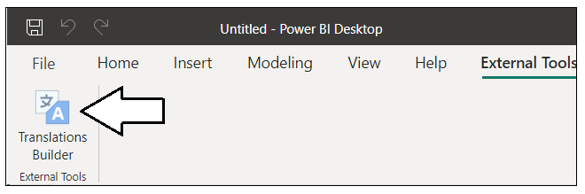

1. Once you see **Translations Builder** start up without an errors, you know it has been installed successfully.

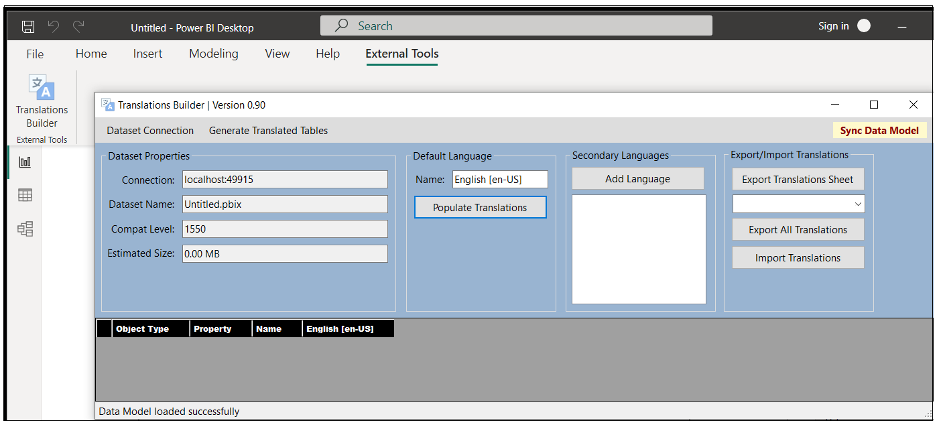

### Troubleshooting

The following information might be important to you if you need to troubleshoot your **Translations Builder** installation. The default **Folder** location for the **Translations Builder** EXE file and other deployment files uses this path.

C:\Program Files\Power BI Dev Camp\Translations Builder

Here is what this folder looks like if you examine it with Windows Explorer.

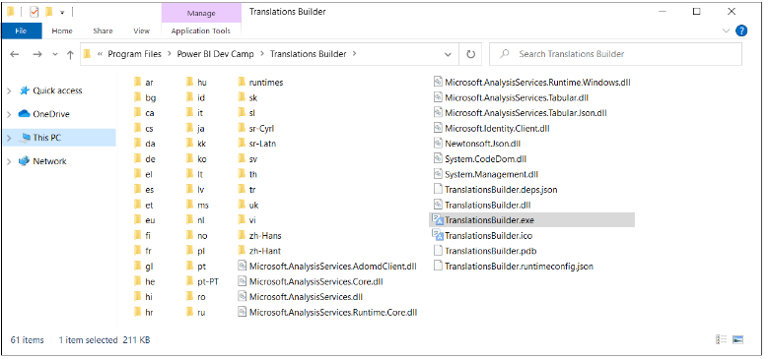

Another essential part of the installation process for an external tool is copying a special deployment file with JSON configuration information into a special folder that is examined by Power BI Desktop as startup. More specifically, the **Translations Builder** installation program copies a file named **translationsbuilder.pbitool.json** into the following folder.

C:\Program Files (x86)\Common Files\Microsoft Shared\Power BI Desktop\External Tools

If you examine this folder, it should contain the file named **translationsbuilder.pbitool.json** along with a separate files with a **\*.pbitool.json** extension for any other external tool that you have installed.

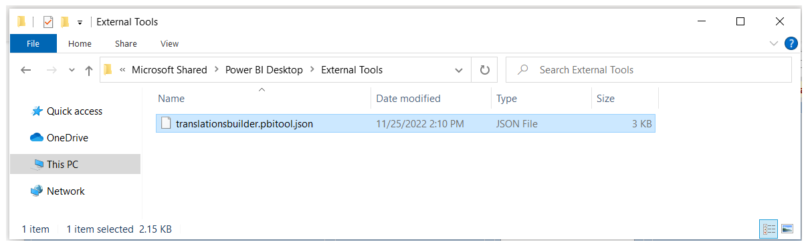

If you open in **translationsbuilder.pbitool.json** in a text editor such as Notepad, you will see it contains a **path** property with a configured file path to **TranslationsBuilder.exe**. This is the file path Power BI Desktop uses to launch **Translations Builder** as an external tools from the **External Tools** tab.

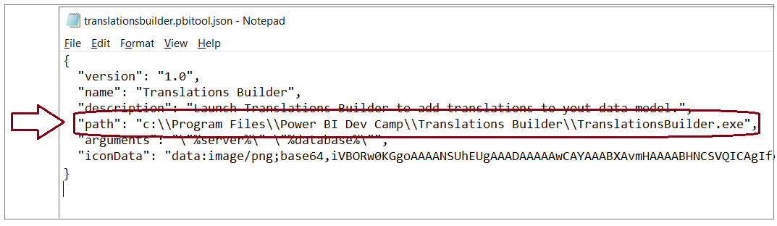

If you installed **Translations Builder** into a **Folder** location other than the default value, you will need to modify the **path** value, save **translationsbuilder.pbitool.json** and restart Power BI Desktop.

### Upgrading Translations Builder to a New Version

When a new version of Translations Builder becomes available, you can upgrade by simply running the installation program again. Running the installation program for a new version Translations Builder will automatically remove the previous version.